Little Kids, Big Adventures: A Guide to Family Hikes Around Knoxville

The Tennessee Valley, Cumberland Plateau, and Great Smoky Mountains National Park

Katie Rosenberg and Joshua Rosenberg

2025-02-01

Table of contents

# Preface

|  |  |
| --- | --- |
|  | Please note - this book will be published by [UT Press](https://utpress.org/) with an expected publication date in early 2026.  This is a **web version with some sample chapters**. Stay tuned for updates on when the book is published and where you can purchase it! |

When we moved to Knoxville in 2018, we arrived as a young family eager to explore but unsure where to begin. Initial, short trips turned into longer, more regular trips that made us start to feel at home.

In “Little Kids, Big Adventures,” we’ve gathered 30 of our favorite trails around Knoxville, chosen not just for scenic beauty but also for their accessibility, variety, and family-friendly qualities.

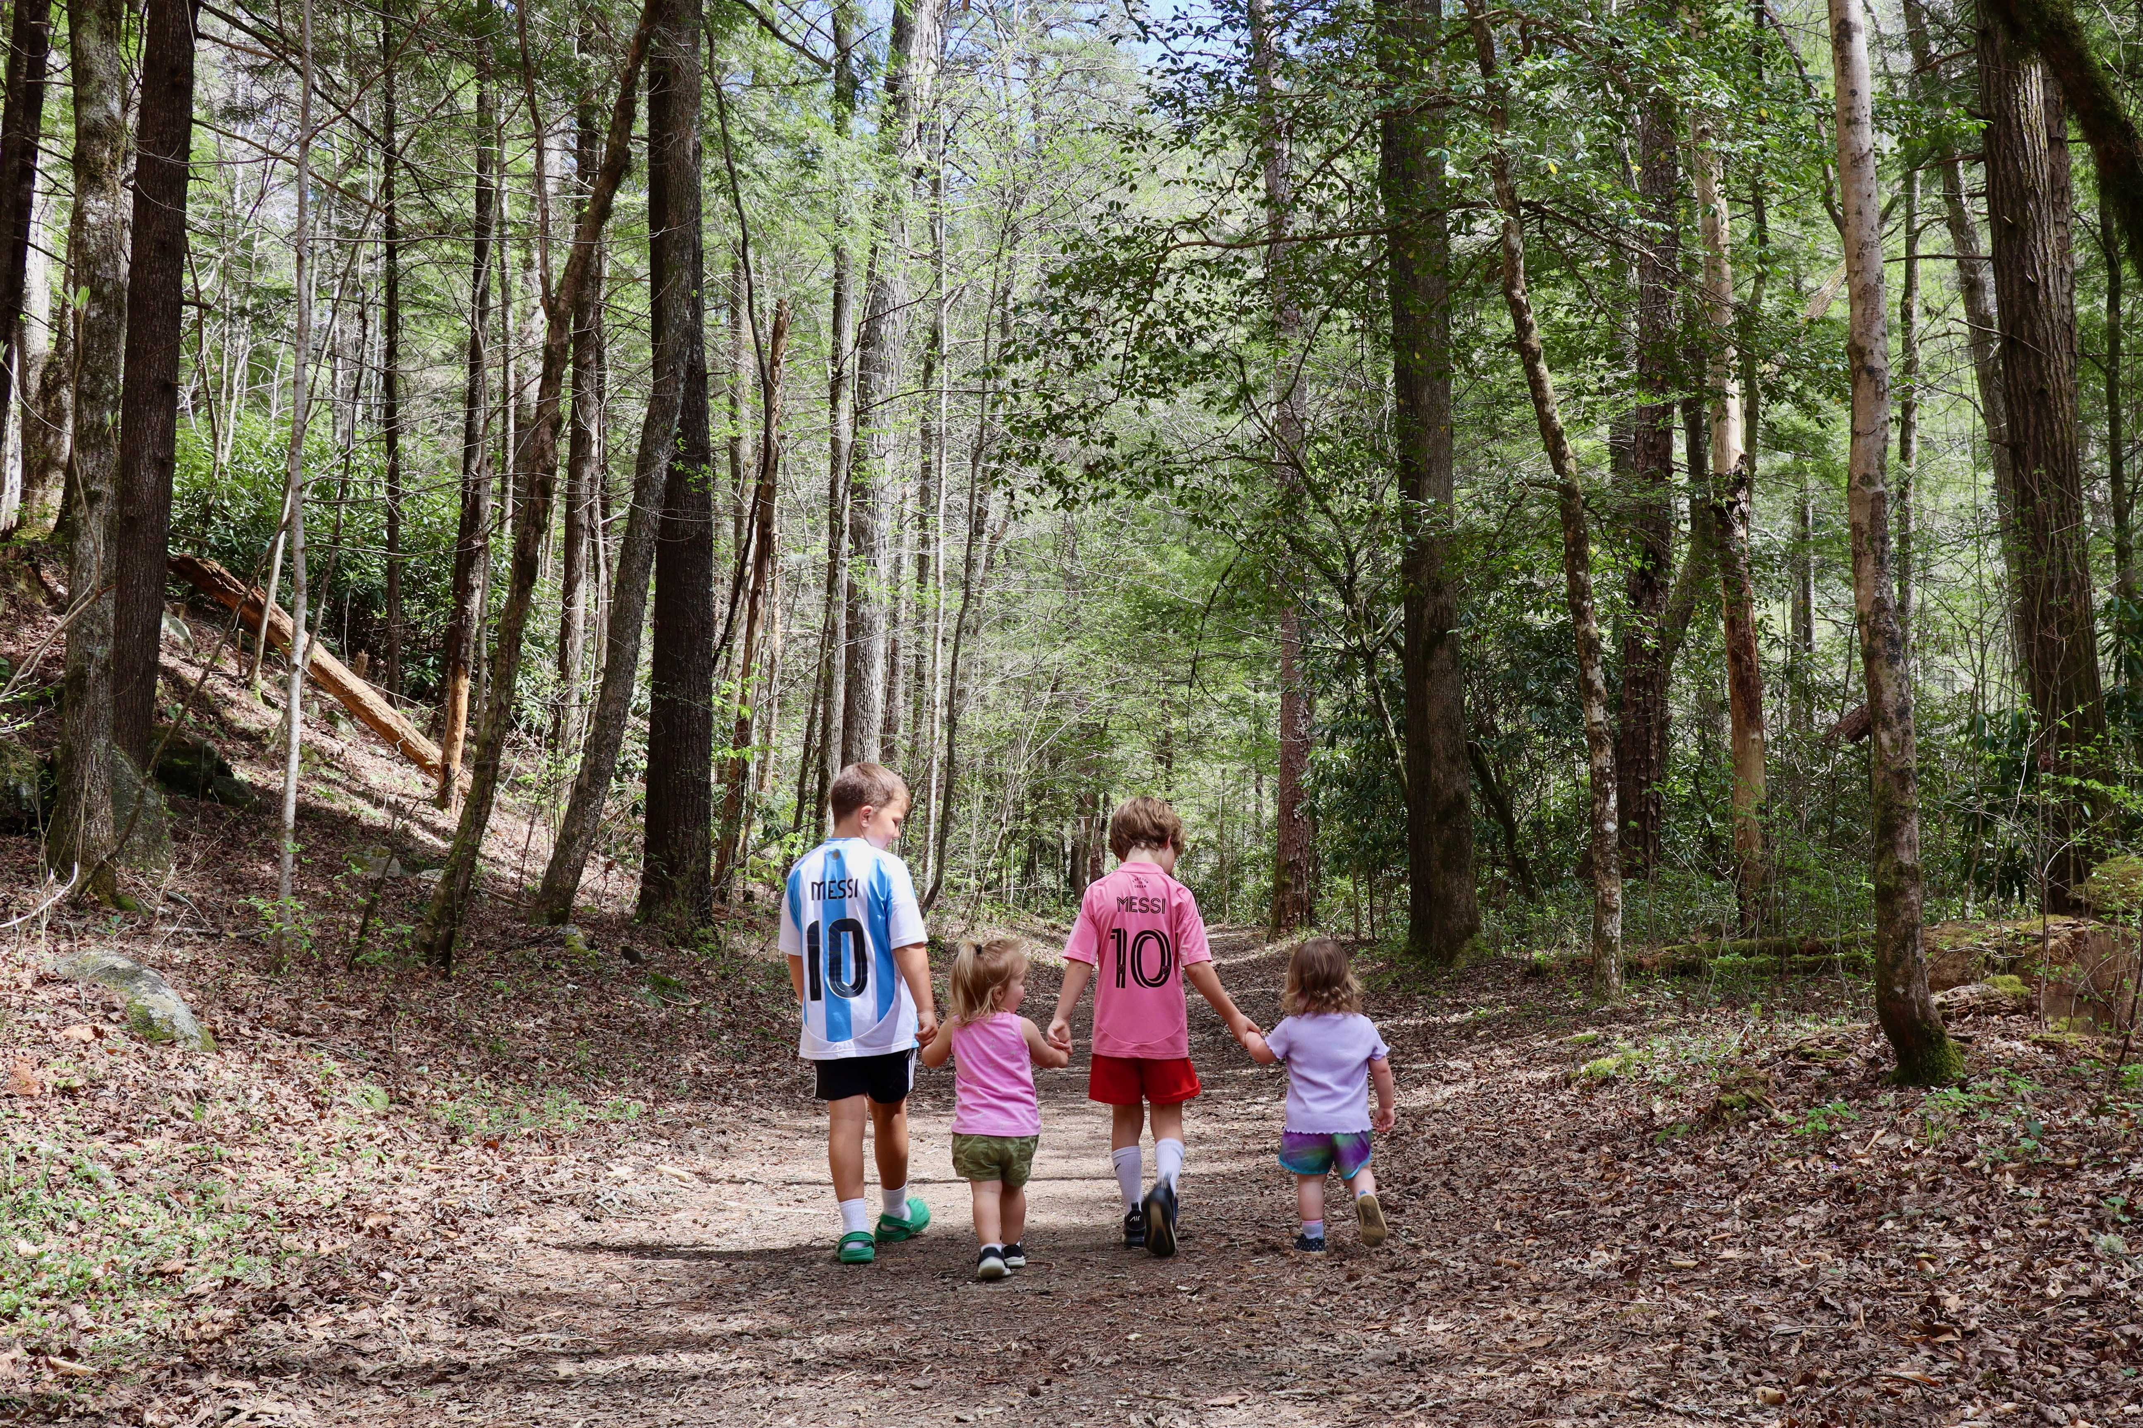

Photo credit to Katie and Joshua Rosenberg

The book is structured to guide you from getting started to expanding your family’s outdoor adventures. Early chapters provide tips for beginners, from how to prepare for your first hike to choosing trails best suited for your family. Subsequent sections dive into specific hikes across three distinct areas: Knoxville, the Cumberland Plateau, and the Great Smoky Mountains National Park. Each trail description is crafted to help you understand what to expect, highlighting kid-friendly features, difficulty levels, accessibility, and scenic highlights.

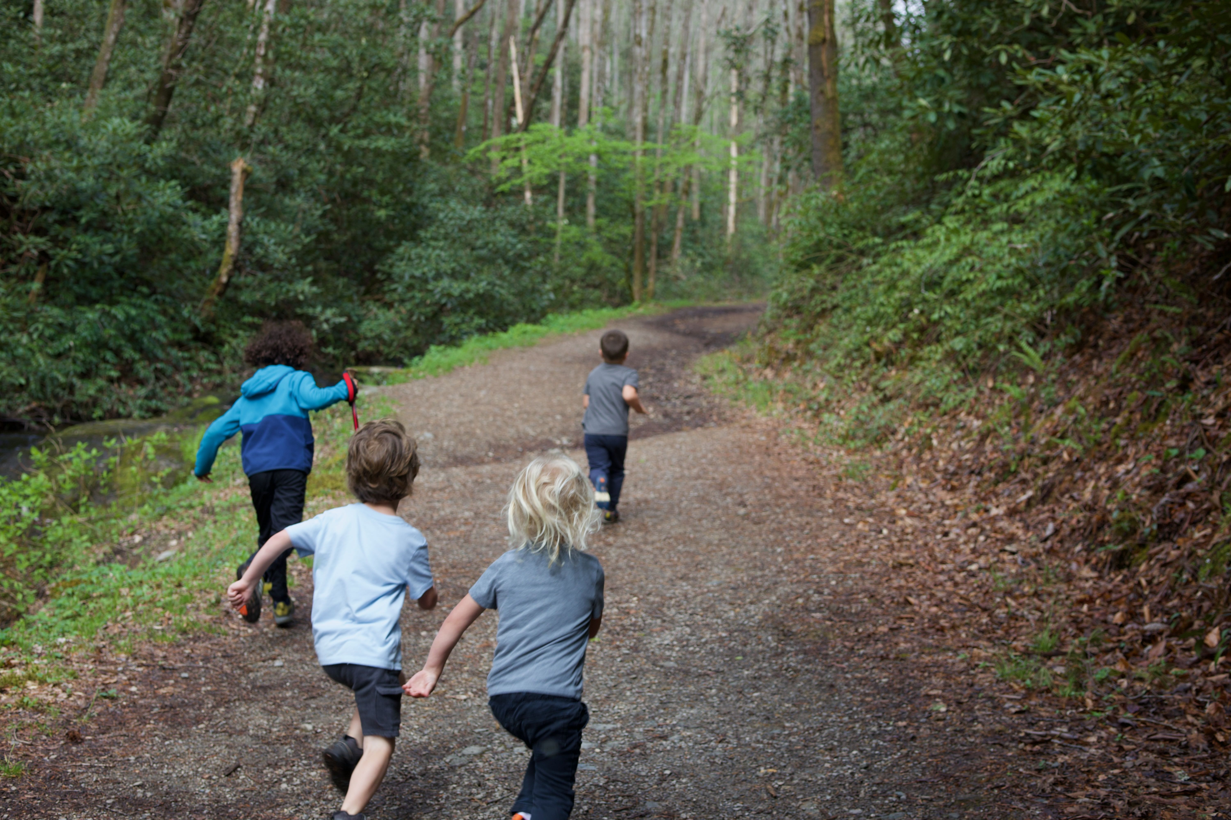

Photo credit to Katie and Joshua Rosenberg

Happy hiking!

# Dedication

To Jonah and Ayla. Time with on these hikes inspired by this book.

# Acknowledgments

Thank you to Sam Weisbrod and family for contributing many of the photos used in this book.

Thank you to MaryRose Weatherton and Amanda Garner for contributing call-outs.

Thank you to Will Fontanez for creating the maps used in this book.

Thanks to Thomas Wells and the team at UT Press for supporting this project from its initial ideation and scope through publishing!

Thank you to the many friends and family members who provided feedback or input on the book: Joel Rosenberg, Teri Rosenberg, Aaron Rosenberg, Judson and Laura Laughter, Enilda and Mac Romero-Hall, Jeff and Sarah Ringer, Earl Whittemore, and Mike Long.

# A story about a hike

Picture this: A sunny day in nature with your family. Your kids happily climb up and over rocks, stopping only to splash in creeks. At the end, you have a picnic on the grass on a perfect, mild but warm day without a bug to be found.

*Record Scratch*

Sure, we’d all love for the above vision to be reality, but the truth is almost always a bit messier and with unexpected bumps in the road.

If you’re like us, you might be ready to throw in the towel before you even leave home. We’ve been there.

However, we’ve also grown as a family who hikes, honed the process, and adjusted our expectations. And sometimes the weather is just right, we and the kiddos are having a great time, and, every once in a while, there really isn’t a bug in sight.

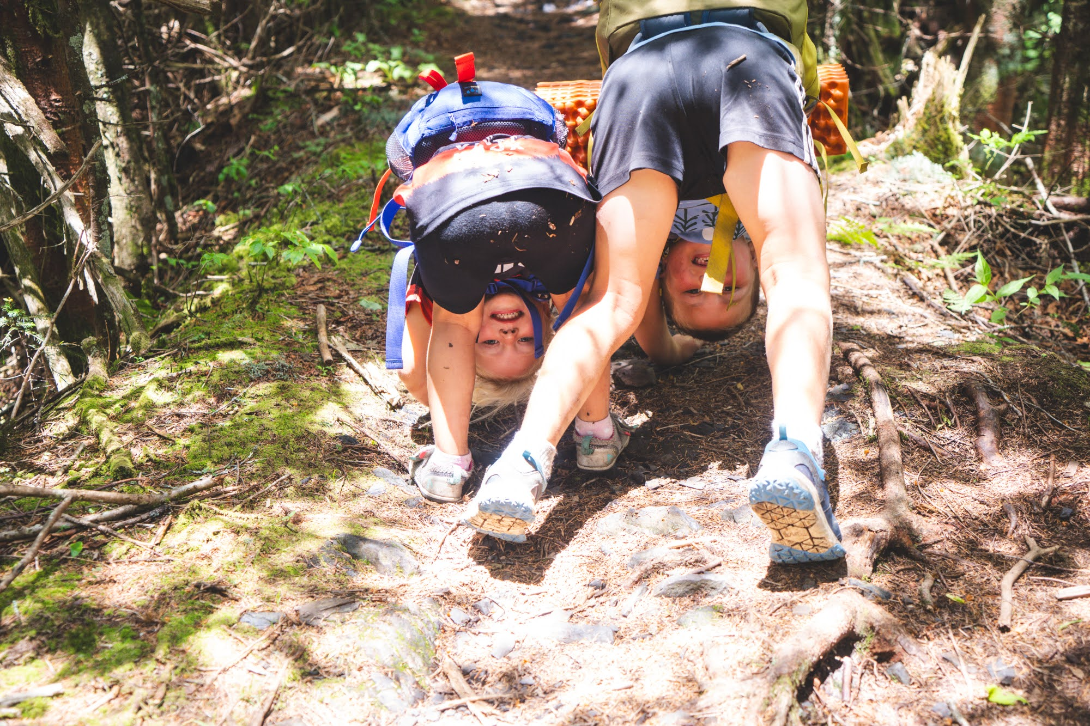

Photo credit to Sam Weisbrod

### We wrote this to help our friends (and you!)

After moving to Knoxville as a very young famiy in 2018, our first trip to Ijams introduced us to Knoxville’s incredible outdoor spaces. Katie discovered Seven Islands, and it was awesome—and close to home. A camping trip at Frozen Head opened our eyes. Later, visiting the Smokies sealed the deal: hiking helped us to feel connected to and later to love where we live.

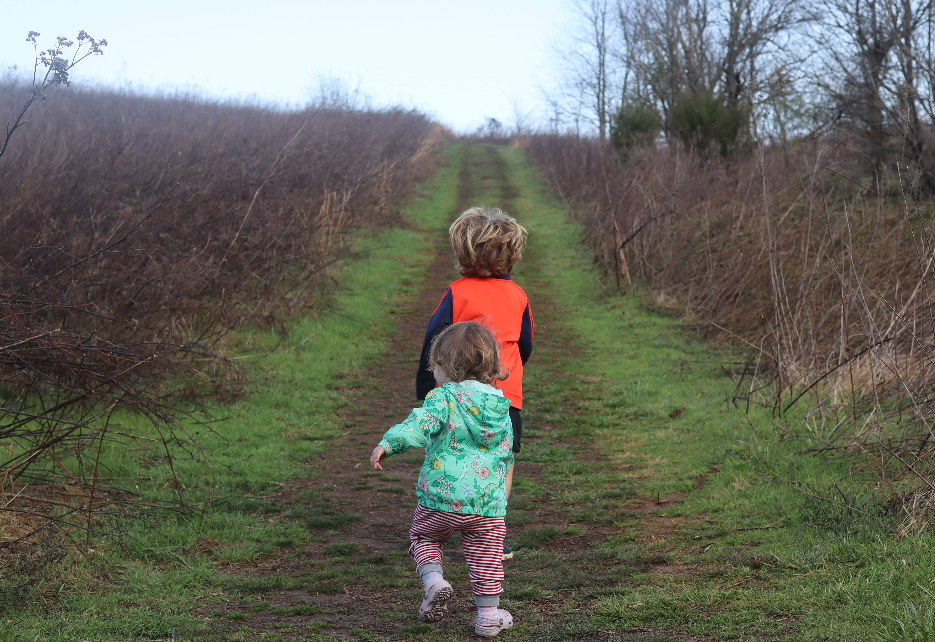

Photo credit to Katie and Joshua Rosenberg

We don’t think we’re very special in this respect (and in most others!): One of the many joys of writing this book was discovering that we’d hiked all 30 of the trails in it.

As we transitioned from newcomers to becoming established, we were increasingly asked questions by our friends:

*Where should we hike with our kids?*

and

*What do I need to hike with our kids?*

This book is meant to answer those questions. But, as a sneak preview, we picked out 30 trails with an eye not only toward the trails that are scenic and exciting, but also those that are likely to balance driving distance, crowds, and kid-friendly characteristics. And, one of the many great parts about hiking is that you don’t need much to get started. Indeed, you may not need anything at all.

### Whom this book is for

This book is for families and others caring for children who are looking for an accessible introduction to getting started hiking around Knoxville. Furthermore, this book is also for those with a few favorite trails looking to do and learn more—find longer, more challenging hikes or be introduced to hidden gems.

Because this book is for those new to hiking and those with some mud on their shoes, we’ve included a wide range of hikes, from those shorter than a mile on paved trails to epic expeditions into the Smokies. Additionally, we’ve noted trails that are stroller-friendly or accessible for families with additional needs.



Photo credit to Katie and Joshua Rosenberg

Read on for things to consider for your first hike (you don’t need much!) and some recommendations for choosing a hike.

# Overview of the Hikes

This overview table includes key information about the 30 hikes. Please see each chapter description for more details, including information about whether pets are allowed, parking passes are required, the availability of restrooms, and the accessibility of the trails for strollers and wheelchairs.

## Overview of the Hikes

| Trail # | **Trail Name** | Location | **Time** | **Distance (Mi.)** | **Elevation** | **Best Ages** |
| --- | --- | --- | --- | --- | --- | --- |
| 1 | **Seven Islands** | Seven Islands State Birding Park | 1.5 - 3 hours | 2.3 | Gentle | Toddlers, Little kids, and Big kids |
| 2 | **Ijams Riverside** | Ijams Nature Center | 45 minutes - 1.5 hours | 1.05 | Moderate | Toddlers and Little Kids |
| 3 | **Lakeshore Park** | Lakeshore Park | 1.5 hours - 2.5 hours | 2.2 | Gentle | Toddlers, Little Kids, and Big Kids |
| 4 | **High Ground Park** | High Ground Park | 0.5 hours - 1 hour | 0.7 | Gentle | Toddlers and Little kids |
| 5 | **UT Arboretum** | University of Tennessee Arboretum | 0.5 hours - 1 hour | 0.9 | Gentle | Toddlers and Little Kids |
| 6 | **Knox-Blount Greenway** | Knox-Blount Greenway | 45 minutes - 1.5 hours | 2.3 | Gentle | Toddlers and Little Kids |
| 7 | **Sequoyah Park** | Sequoyah Park | 1 hour - 2 hours | 2.1 | Flat | Toddlers and Little Kids |
| 8 | **Ijams Crag** | Ijams Nature Center | 45 minutes - 1.5 hours | 1.5 | Moderate | Little Kids and Big Kids |
| 9 | **William Hastie** | William Hastie Natural Area | 0.5 hours - 1 hour | 1.3 | Flat | Toddler and little kids |
| 10 | **Sharp’s Ridge** | Sharp’s Ridge Memorial Park | 1.5 hours - 2.5 hours | 2.3 | Moderate | Little kids |
| 11 | **Norris Dam** | Norris Dam State Park | 1.5 hours - 2.5 hours | 2.3 | Gentle | Little kids and Big kids |
| 12 | **House Mountain** | House Mountain State Natural Area | 2.5 hours - 4.5 hours | 2.5 | Steep | Pre-teens and older |
| 13 | **Emory Falls at Frozen Head** | Frozen Head State Park | 2 hours - 3.5 hours | 2.4 | Moderate | Little kids |
| 14 | **The Obed Point Trail** | Obed Wild & Scenic River | 2.5 hours - 4.5 hours | 3.6 | Gentle | Little kids and Big kids |
| 15 | **Bandy Creek Campground** | Big South Fork NRRA | 45 minutes - 1.25 hours | 1.3 | Flat | Toddlers and Little kids |
| 16 | **Fall Branch Falls** | Big South Fork NRRA | 2.5 hours - 4.5 hours | 3.7 | Moderate | Big kids and Pre-teens and older |
| 17 | **Twin Arches** | Big South Fork NRRA | 1.5 hour - 2.5 hours | 1.2 | Moderate | Little kids and Big kids |
| 18 | **Angel Falls Overlook** | Big South Fork NRRA | 1.5 hours - 2.5 hours | 2.8 | Gentle | Little Kids and Big Kids |
| 19 | **Honey Creek** | Big South Fork NRRA | 4 hours - 7 hours | 4.4 | Steep | Big kids and Pre-teens and older |
| 20 | **Spruce Flats Falls** | Great Smoky Mountains NP | 1.5 hours - 2.5 hours | 1.6 | Moderate | Big kids and Pre-teens and older |
| 21 | **Little River** | Great Smoky Mountains NP | 3 hours - 5 hours | 5.5 | Moderate | Little kids, Big kids, and Pre-teens and older |
| 22 | **Mouse Creek** | Great Smoky Mountains NP | 2 hours - 4 hours | 4.0 | Moderate | Little kids and Big kids |
| 23 | **Whiteoak Sink** | Great Smoky Mountains NP | 3 hours - 5 hours | 4.6 | Moderate | Little kids and Big kids |
| 24 | **Middle Prong** | Great Smoky Mountains NP | 4 hours - 6 hours | 7.6 | Moderate | All Ages |
| 25 | **Abrams Creek** | Great Smoky Mountains NP | 4 hours - 6 hours | 5.8 | Moderate | All ages |
| 26 | **Look Rock** | Great Smoky Mountains NP | 30 minutes - 1 hour | 0.6 | Moderate | Toddlers and Little Kids |
| 27 | **Chestnut Top** | Great Smoky Mountains NP | 1.5 hours - 2.5 hours | 2.6 | Steep | Big kids |
| 28 | **Abrams Falls** | Great Smoky Mountains NP | 2.5 hours - 3 hours | 5.0 | Steep | Big kids and Pre-teens and older |
| 29 | **Andrews Bald** | Great Smoky Mountains NP | 2 hours - 3.5 hours | 3.6 | Moderate | Big kids and Pre-teens and older |
| 30 | **Alum Cave Bluffs** | Great Smoky Mountains NP | 3 hours - 5 hours | 4.5 | Very Steep | Big kids and Pre-teens and older |

# Trail 1: Seven Islands

### Overview

This is one of our favorite trails in this book, and it is the first trail for that reason! This hike is a crowd pleaser for every family member of all ages thanks to a paved path that makes bringing babies in a stroller a breeze and easy acces to experience meadow, woodland, and a river! For the trail we highlight, a paved path descends through a meadow. Look for varied bird varieties and deer in all seasons! The trail crosses a bridge over the French Broad River and then a dirt trail make a loop around a beautiful island before returning back to the paved path. This hike is great for all ages and seasons, though it is sometimes hot in the summer due to limited shade on the paved part of the trail.

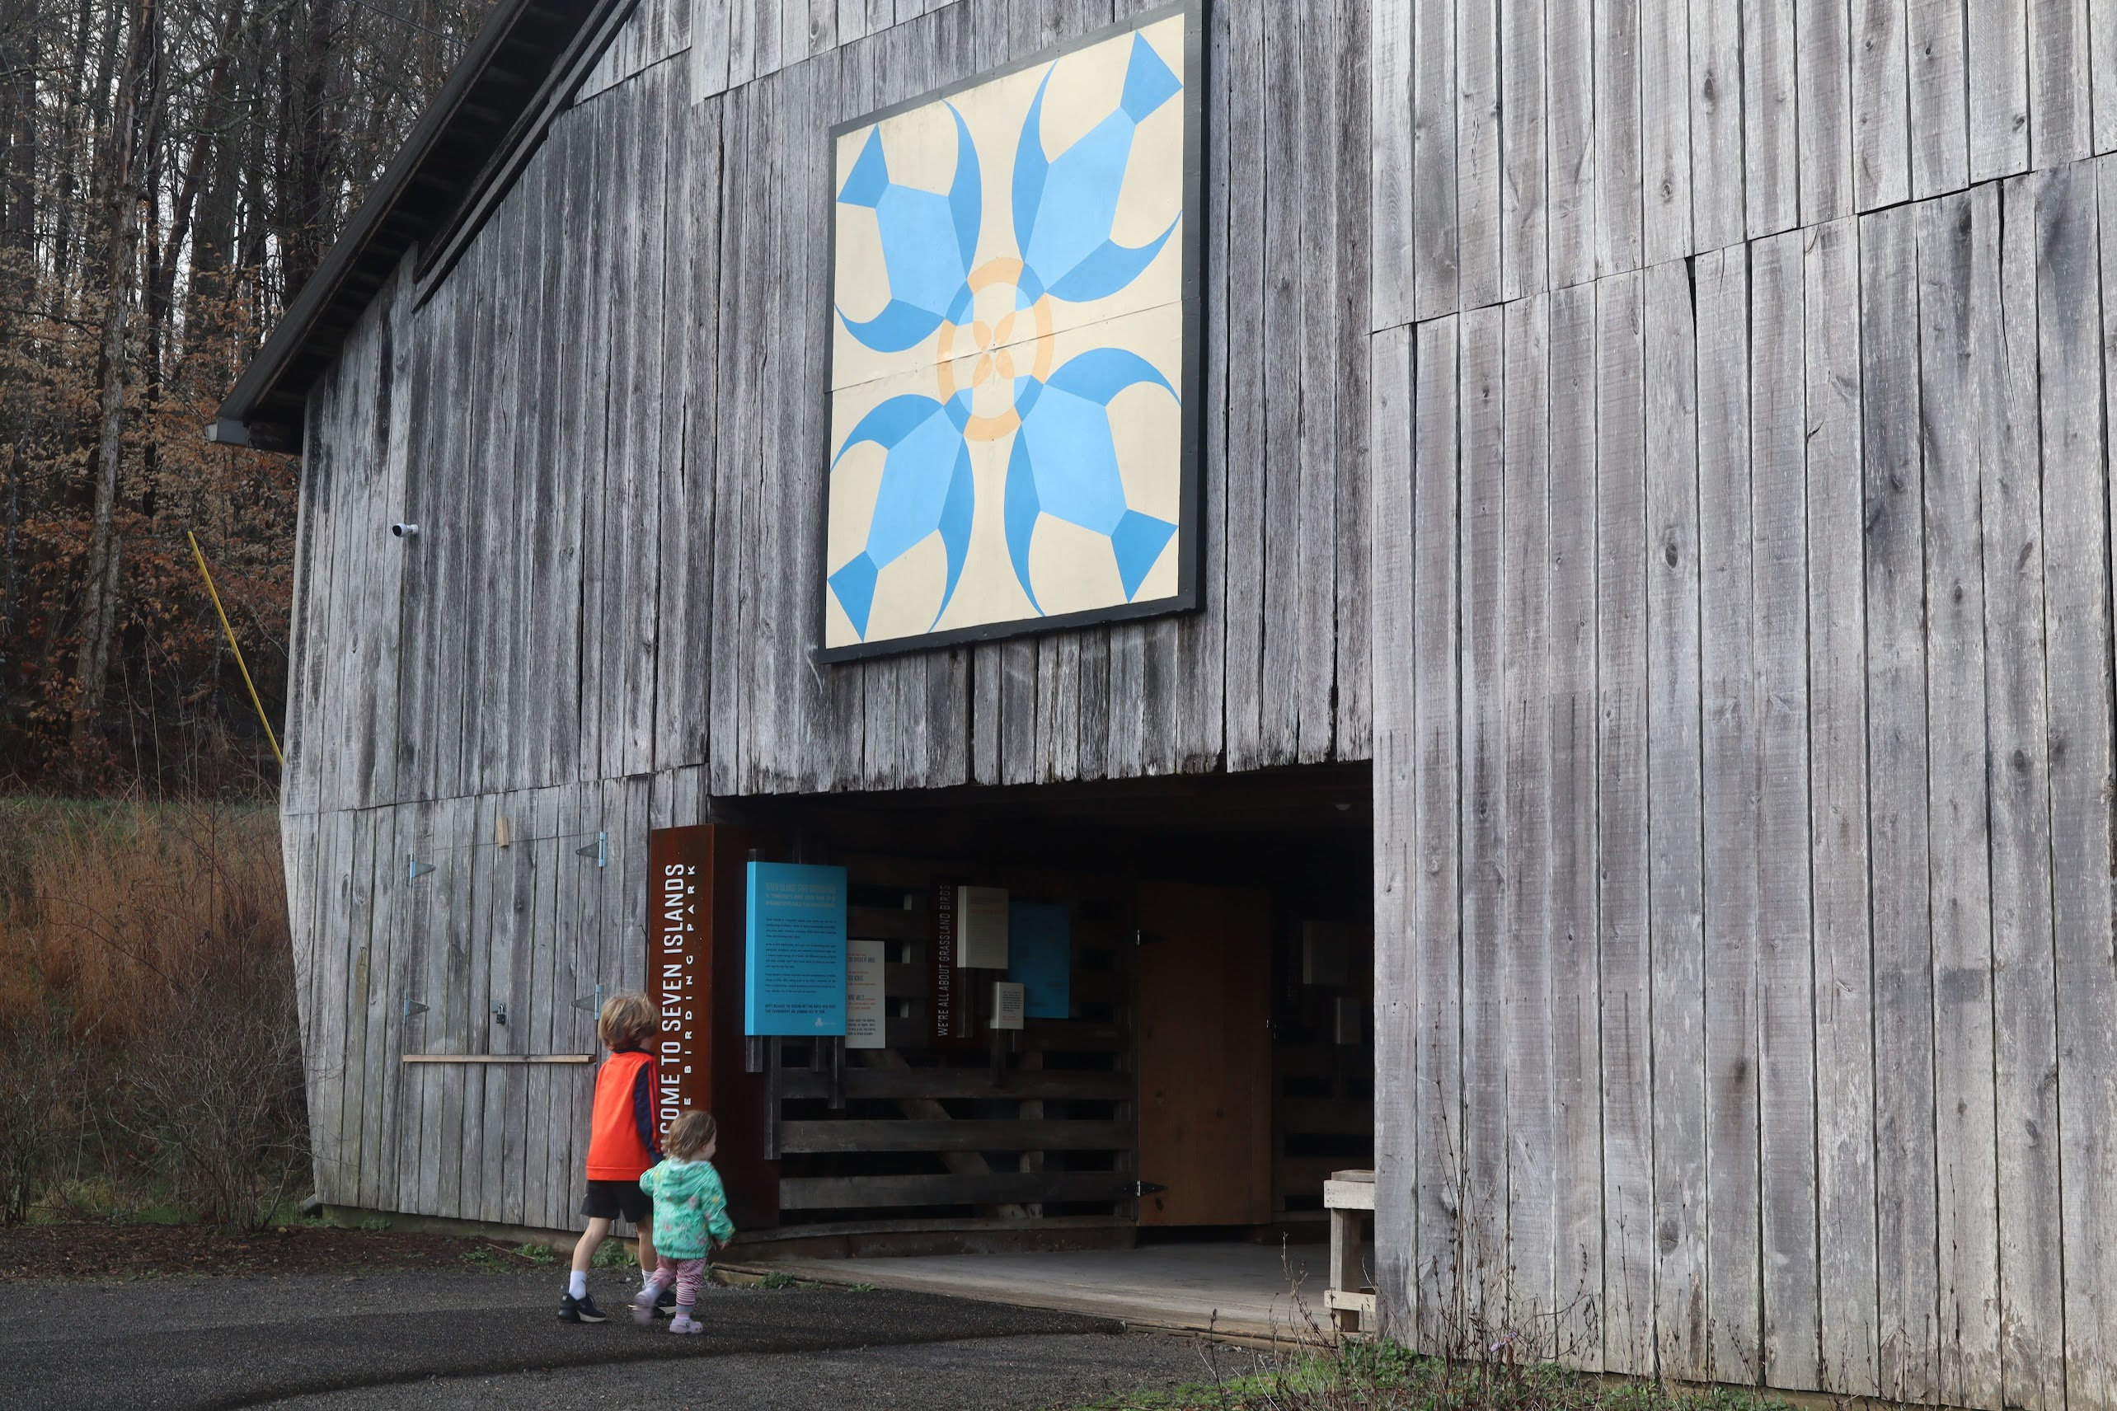

Photo credit to Katie and Joshua Rosenberg

### Key Characteristics

| **Characteristic** | **Details** |
| --- | --- |
| Time Estimate - Hiking Fast | 1.5 - 3 hours |
| Trail Distance (Miles) | 2.3 |
| Elevation Change | Gentle |
| Pets | Allowed on leash |
| Parking Pass/Entrance Fee | Not Required |
| Restroom(s) | Yes |
| Best Ages | Toddlers, Little kids, and Big kids |
| Strollers and Wheelchairs | Partially accessible (path is paved until the island portion) |

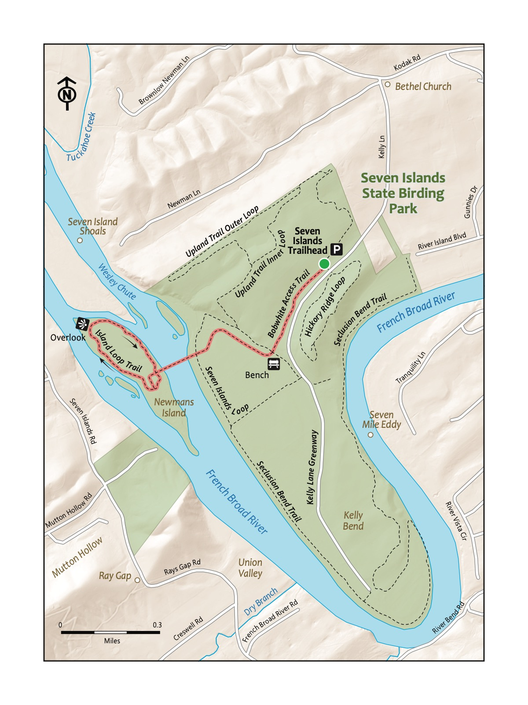

### Directions to the Trailhead

Trailhead Address: Seven Islands State Birding Park, 2809 Kelly Ln, Kodak, TN 37764

Trailhead GPS Coordinates: 35.95366, -83.68701

Park in the large gravel lot (note there is another parking area by a boat launch that is not the correct location for this hike!). We have never had trouble finding a spot even on the busiest of days.

|  |  |
| --- | --- |
|  | **Paw Paw**  A native fruit found around Seven Islands. Tastes like a mix of an apple and a banana. Look for the paw paw grove on the island, but please take care to not damage or eat any of these fruits! |

### Trail Description

| Distance from Start | Description |
| --- | --- |
| 0.0 | Access the Bobwhite Access Trail by walking around or through the barn. |
| 0.05 | Bathroom on the left of the trail. |
| 0.1 | Descend through grassy meadows with wildflowers in the spring and early fall. |
| 0.3 | Bench makes for a nice rest spot. |
| 0.6 | Start of the Newmans Island Bridge. |
| 0.8 | Paved trail ends. Turn right onto the Island Loop Trail to hike around the island. The paw paw grove is off to the left soon after you begin hiking clockwise around the island. Can you find one? |
| 0.85 | Picnic table beside a pretty part of the French Broad River. |
| 1.05 | Stick house (kiddo favorite!). |
| 1.5 | Connect back to the bridge, heading back onto the Bobwhite Access Trail. |
| 2 | Climb back up the Bobwhite Access Trail to the trailhead. |
| 2.3 | Trailhead. |

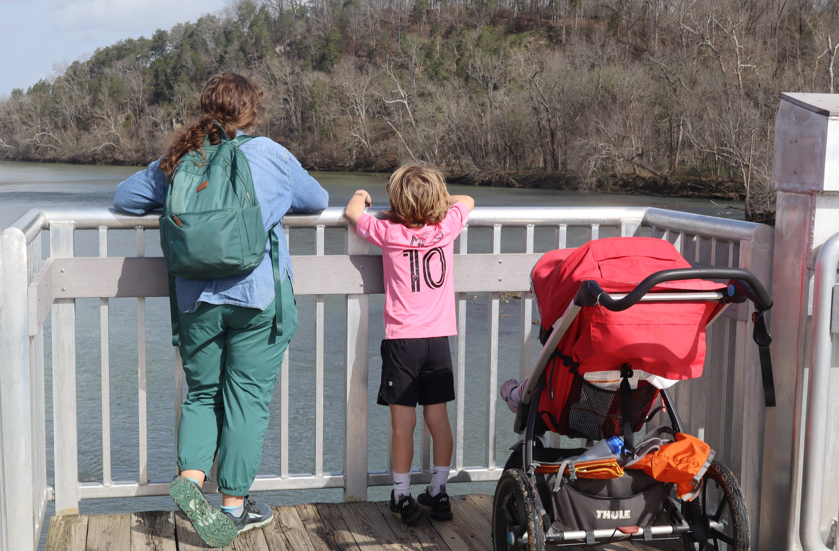

Photo credit to Katie and Joshua Rosenberg

### Nearby

|  |  |
| --- | --- |
|  | **Eastern Bluebird**  While many birds stop over at Seven Islands and areas like that on their migratory routes south (in the fall) and north (in the spring), the Eastern Bluebird is a year-round resident. Bluebirds are obligate cavity nesters - which is why they have experienced such a decline in their population as urban sprawl has increased. Refuges like Seven Islands give them lots of opportunities to find natural cavities to nest in!  -MaryRose Weatherton |

* **Take advantage of the other trails nearby!** Hike up the Hickory Ridge trail, another trail at Seven Islands State Birding Park, that is accessible from just behind the bathrooms near the parking lot. There are several other great hikes available, including hikes down the Kelly Lane Greenway (the other, wider, paved path near the barn that is gated to prevent cars from driving on it) and the Upland Inner and Outer Trail Loops.



Photo credit to Katie and Joshua Rosenberg

* **Bring your canoe, kayak, or paddle board for even more adventures!** Access parking by Also, River Sports Outfitters rents kayaks and canoes here during the summer (see https://www.riversportsoutfitters.com/).
* **Stop for a bite to eat and a drink on the way back!** Consider stopping by kid-friendly Walnut Springs Winery (1175 Midway Rd, Knoxville, TN 37914), open Wednesday-Sunday as of this writing.

# Trail 13: Emory Falls at Frozen Head

### Overview

Writing about this trail makes us smile. In many ways, it’s the perfect kid hike! It starts at a beautiful trailhead along a pretty creek in the deep woods. It gradually climbs before stopping at one of two scenic waterfall, DeBord Falls, and is a perfectly acceptable place to turn around with younger kids (we have many times!). It continues further to Emory Falls before returning on a gradual slope back to the trailhead. Stop at the playground you passed on the way to the trailhead beside the same creek; the water is usually shallow enough to be perfect for splashing and rock hopping. Please note, the trail is rocky, and your kids will likely need reminders to slow down!

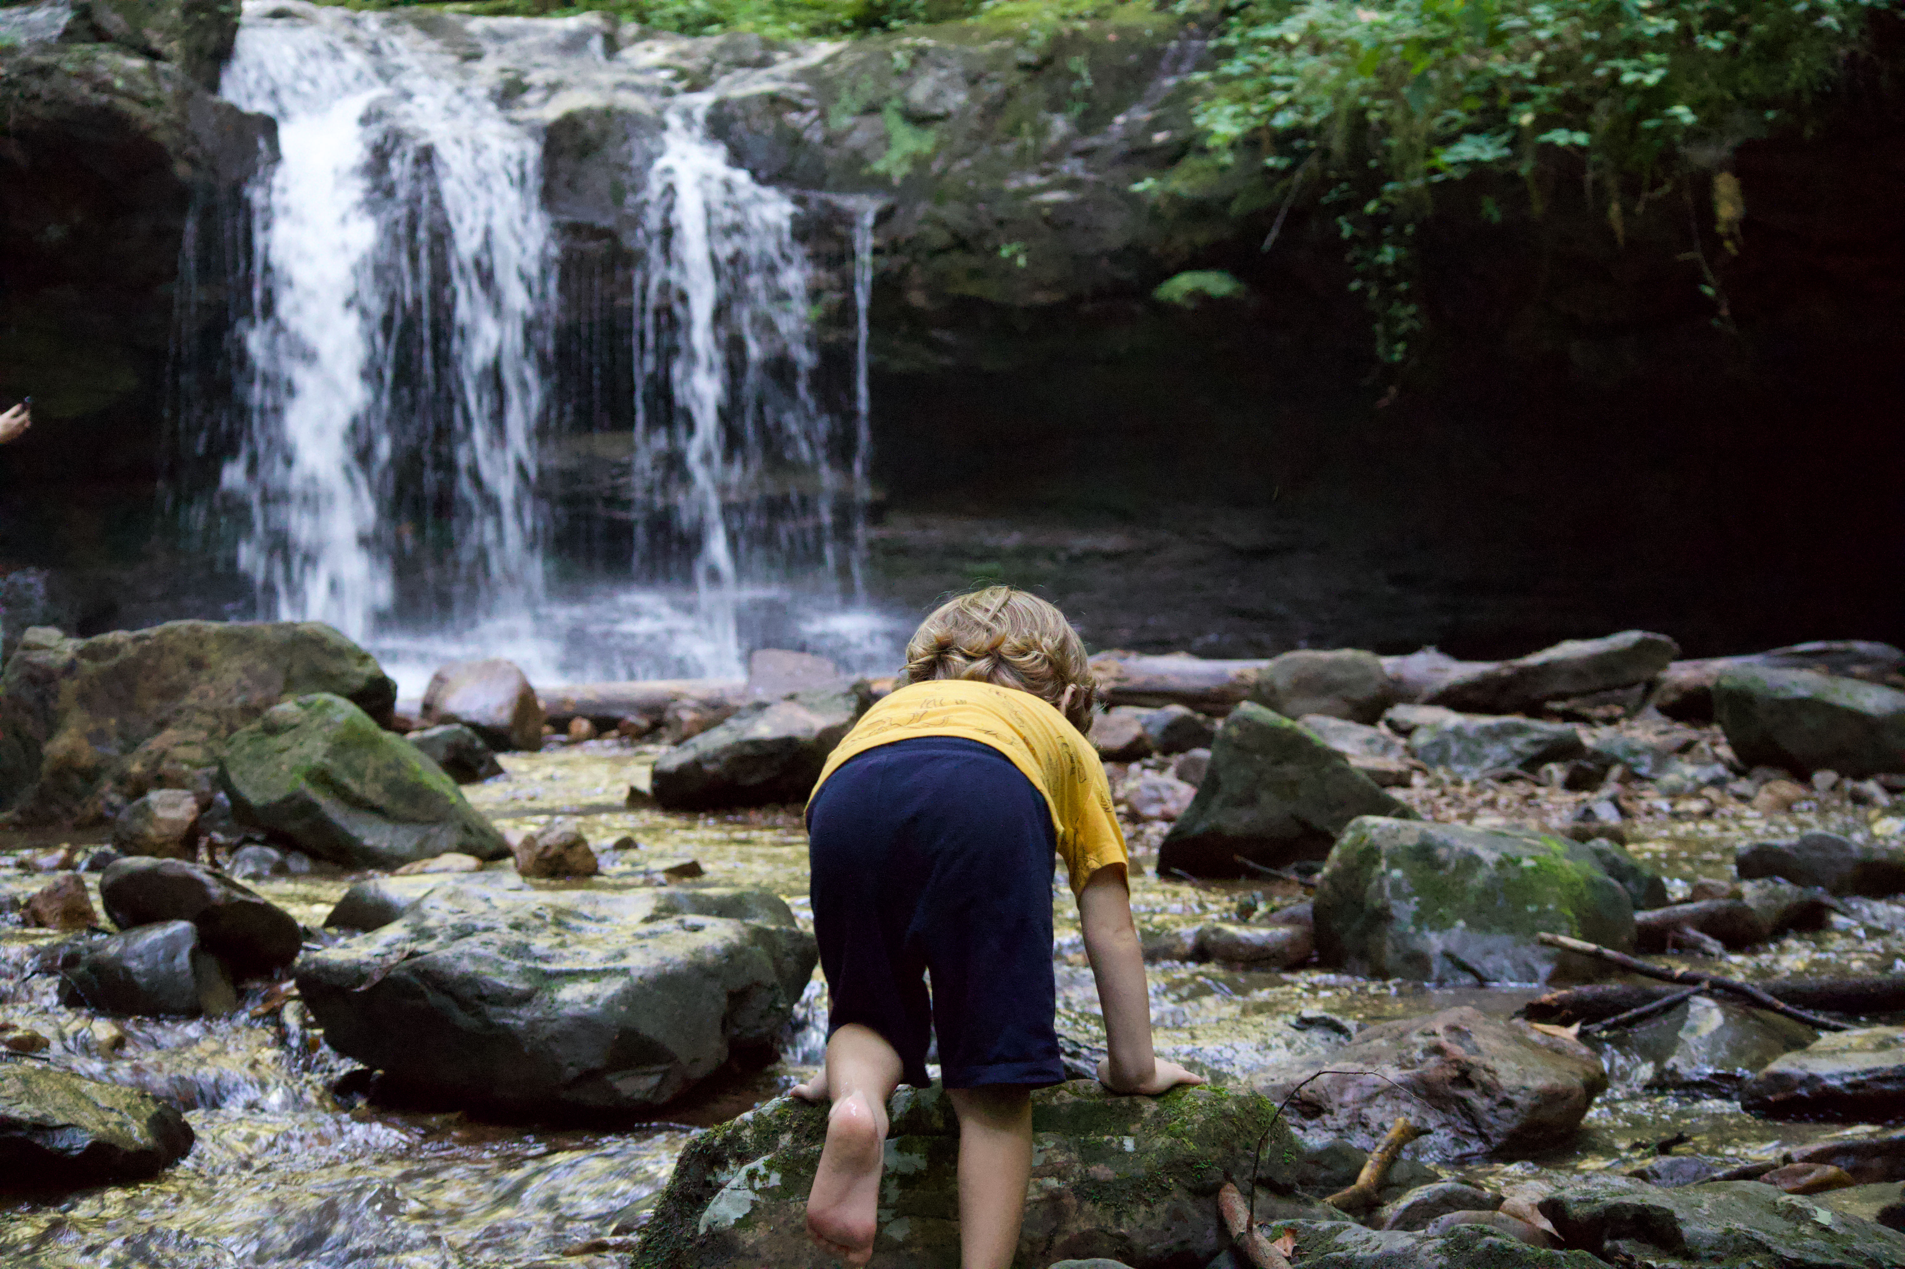

Photo credit to Katie and Joshua Rosenberg

### Key Characteristics

| **Characteristic** | **Details** |
| --- | --- |
| Time Estimate | 2 hours - 3.5 hours |
| Trail Distance (Miles) | 2.4 |
| Elevation Change | Moderate |
| Pets | Allowed on leash |
| Parking Pass/Entrance Fee | Not Required |
| Restroom(s) | No restrooms at the trailhead parking, but you will pass restrooms on the right about three quarters of a mile before the trailhead parking area. |
| Best Ages | Little kids |
| Strollers and Wheelchairs | Not accessible |

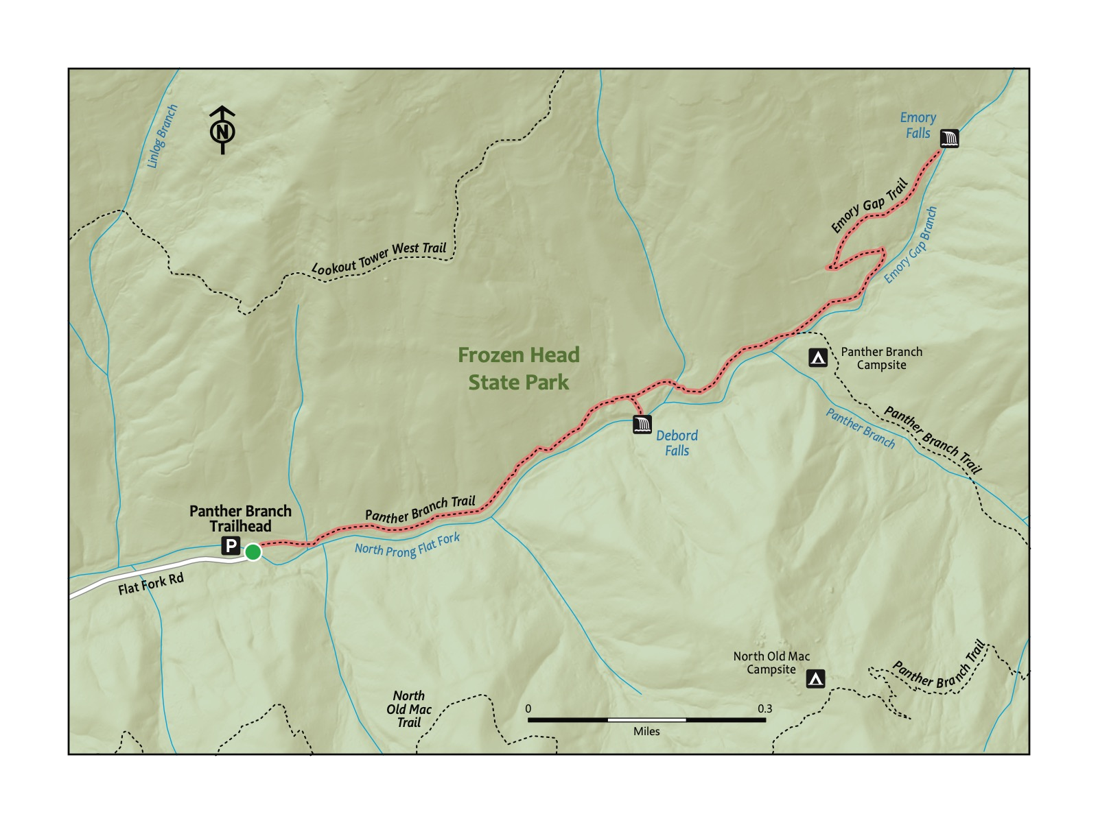

### Directions to the Trailhead

Trailhead Address: Emory Gap Trailhead, 4GP6+MV, Wartburg, TN 37887

Trailhead GPS Coordinates: 36.13658, -84.48785

Park at the Emory Gap Trailhead. Note that the above address uses a “Plus code” that will only work in Google Maps—because Emory Gap Trailhead does not have a street address.

|  |  |
| --- | --- |
|  | **Brushy Mountain State Penitentiary**  A closed prison near Frozen Head State Park is full of lore due to its remote location. Part of the inspiration for the Barkley Marathons (you’ll have to look it up). Now the site of a restaurant and distillery. |

### Trail Description

| Distance from Start | Description |
| --- | --- |
| 0.0 | Start by walking across the bridge at the trailhead. |
| 0.55 | DeBord Falls. Walk down the (steep!) stairs on the right to view the waterfall from below. Optional turnaround spot. |
| 0.9 | Trail switchbacks. |
| 1.1 | Steep and rocky section at the end to the viewing spot for Emory Falls. |
| 1.2 | After viewing the waterfall, head back to the start! |
| 2.4 | Trailhead. |

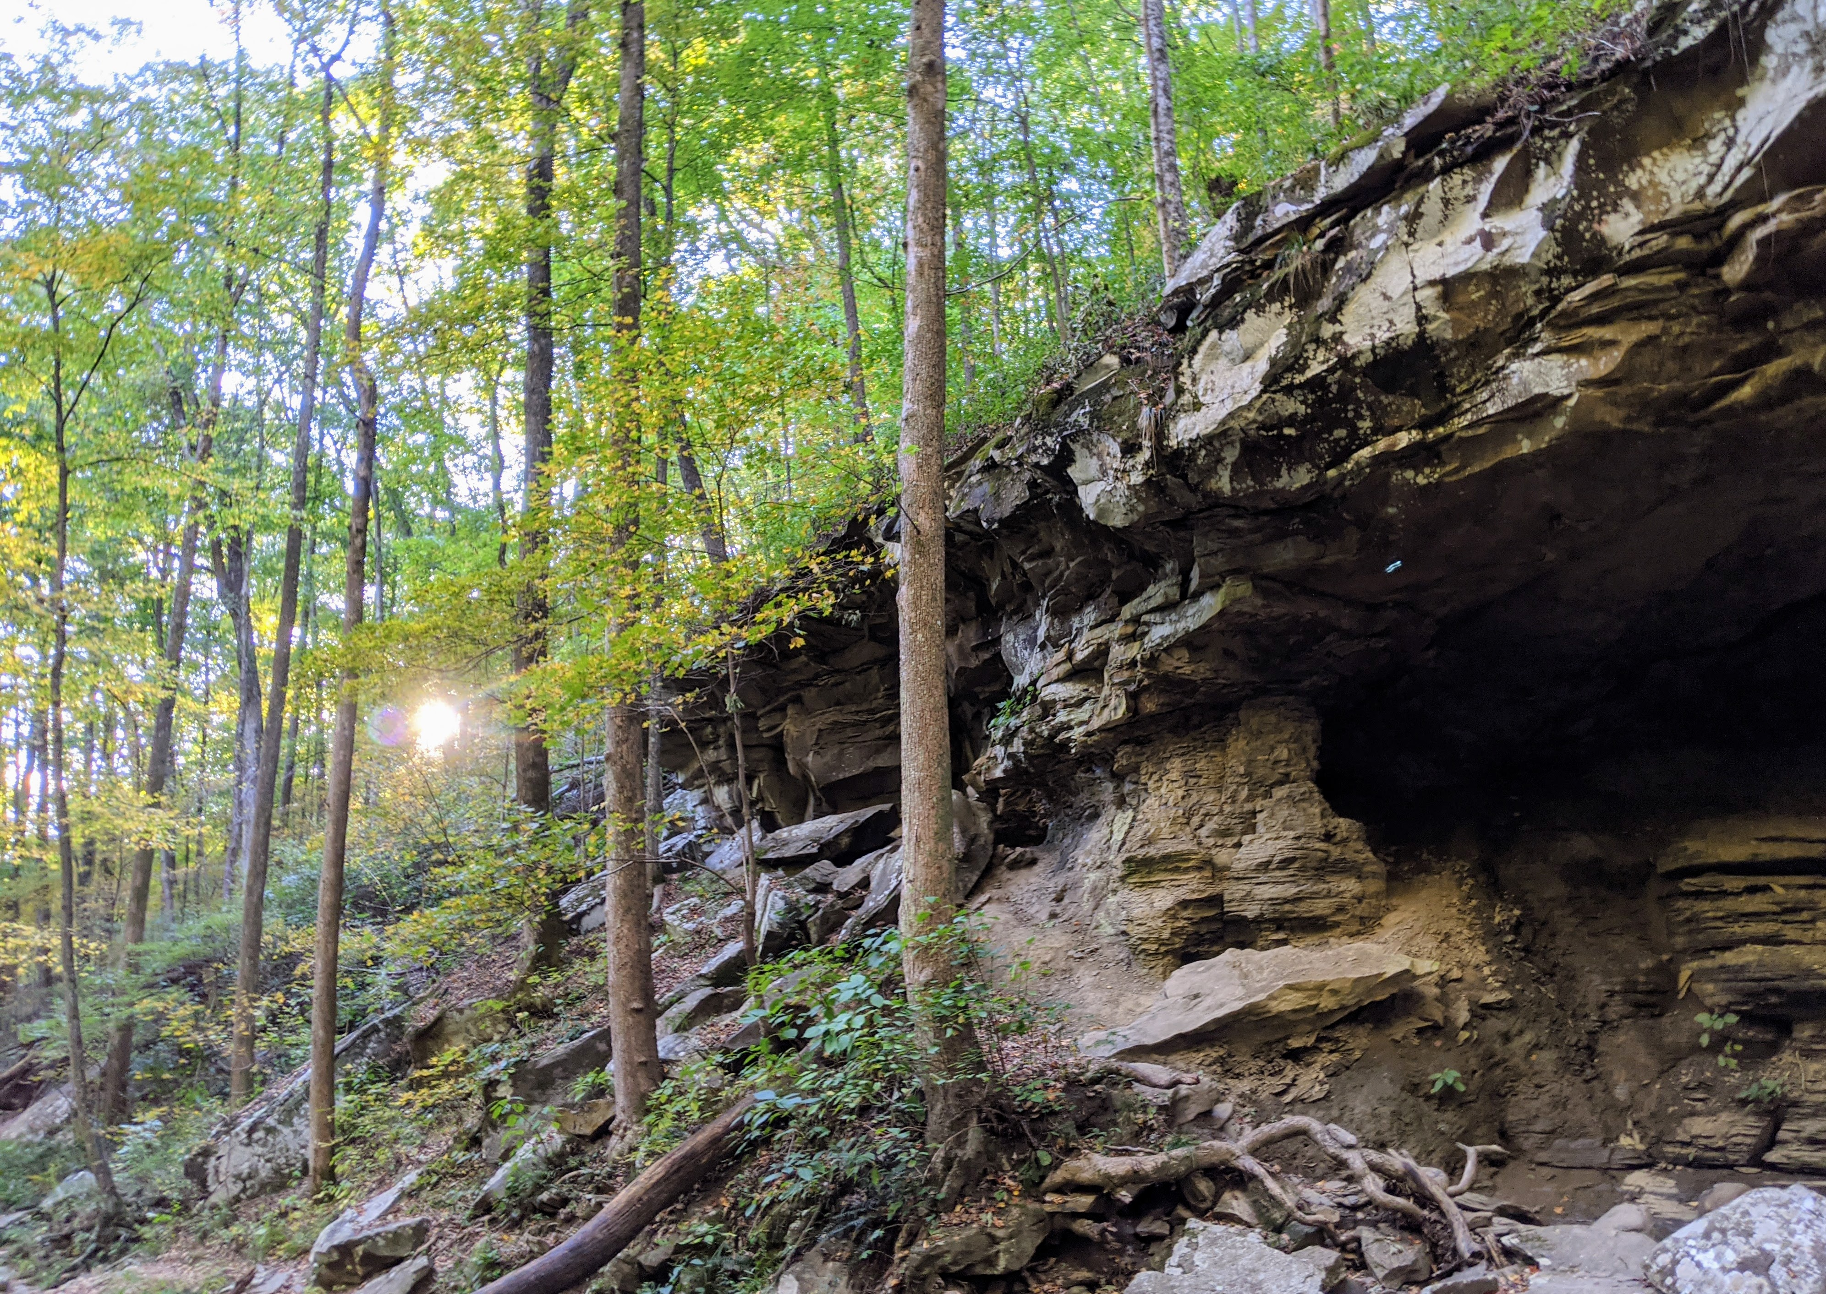

Photo credit to Katie and Joshua Rosenberg

### Nearby

* **Enjoy the playground!** There is a fun, shaded creekside playground 0.7 miles down the road from the trailhead. Most of the year, the creek is a perfect depth for safe splashing.
* **Check out the Flat Fork Story Book Trail.** Starting near the playground, this short trail is great for the littlest hikers.
* **Hike to the Frozen Head Mountain Summit.** A challenge for the biggest kid hikers and adults! This hike is around seven strenuous miles to and back from the Lookout Tower at the summit of Frozen Head Mountain, from which views of the Smokies far in the distance can be faintly visible on clear days.

# Trail 24: Middle Prong

### Overview

This hike is great for families looking to have an authentic hiking experience deep in the Smokies, while still being only a little over an hour’s drive from Knoxville. A benefit of this hike is the early payoff on this scenic trail. It’s only 0.6 miles to the waterfall, but along a stream that affords many chances to hop in and splash. The turn-around spot is an overlook to a waterfall, Lynn Camp Prong, though the trail continues after the cascades up to another waterfall, Indian Flats Falls. Given the ample shade and easy access to the stream, this is a great hike for the summer, but it is enjoyable in all seasons. Good for kids of all ages because you can turn around at any point.

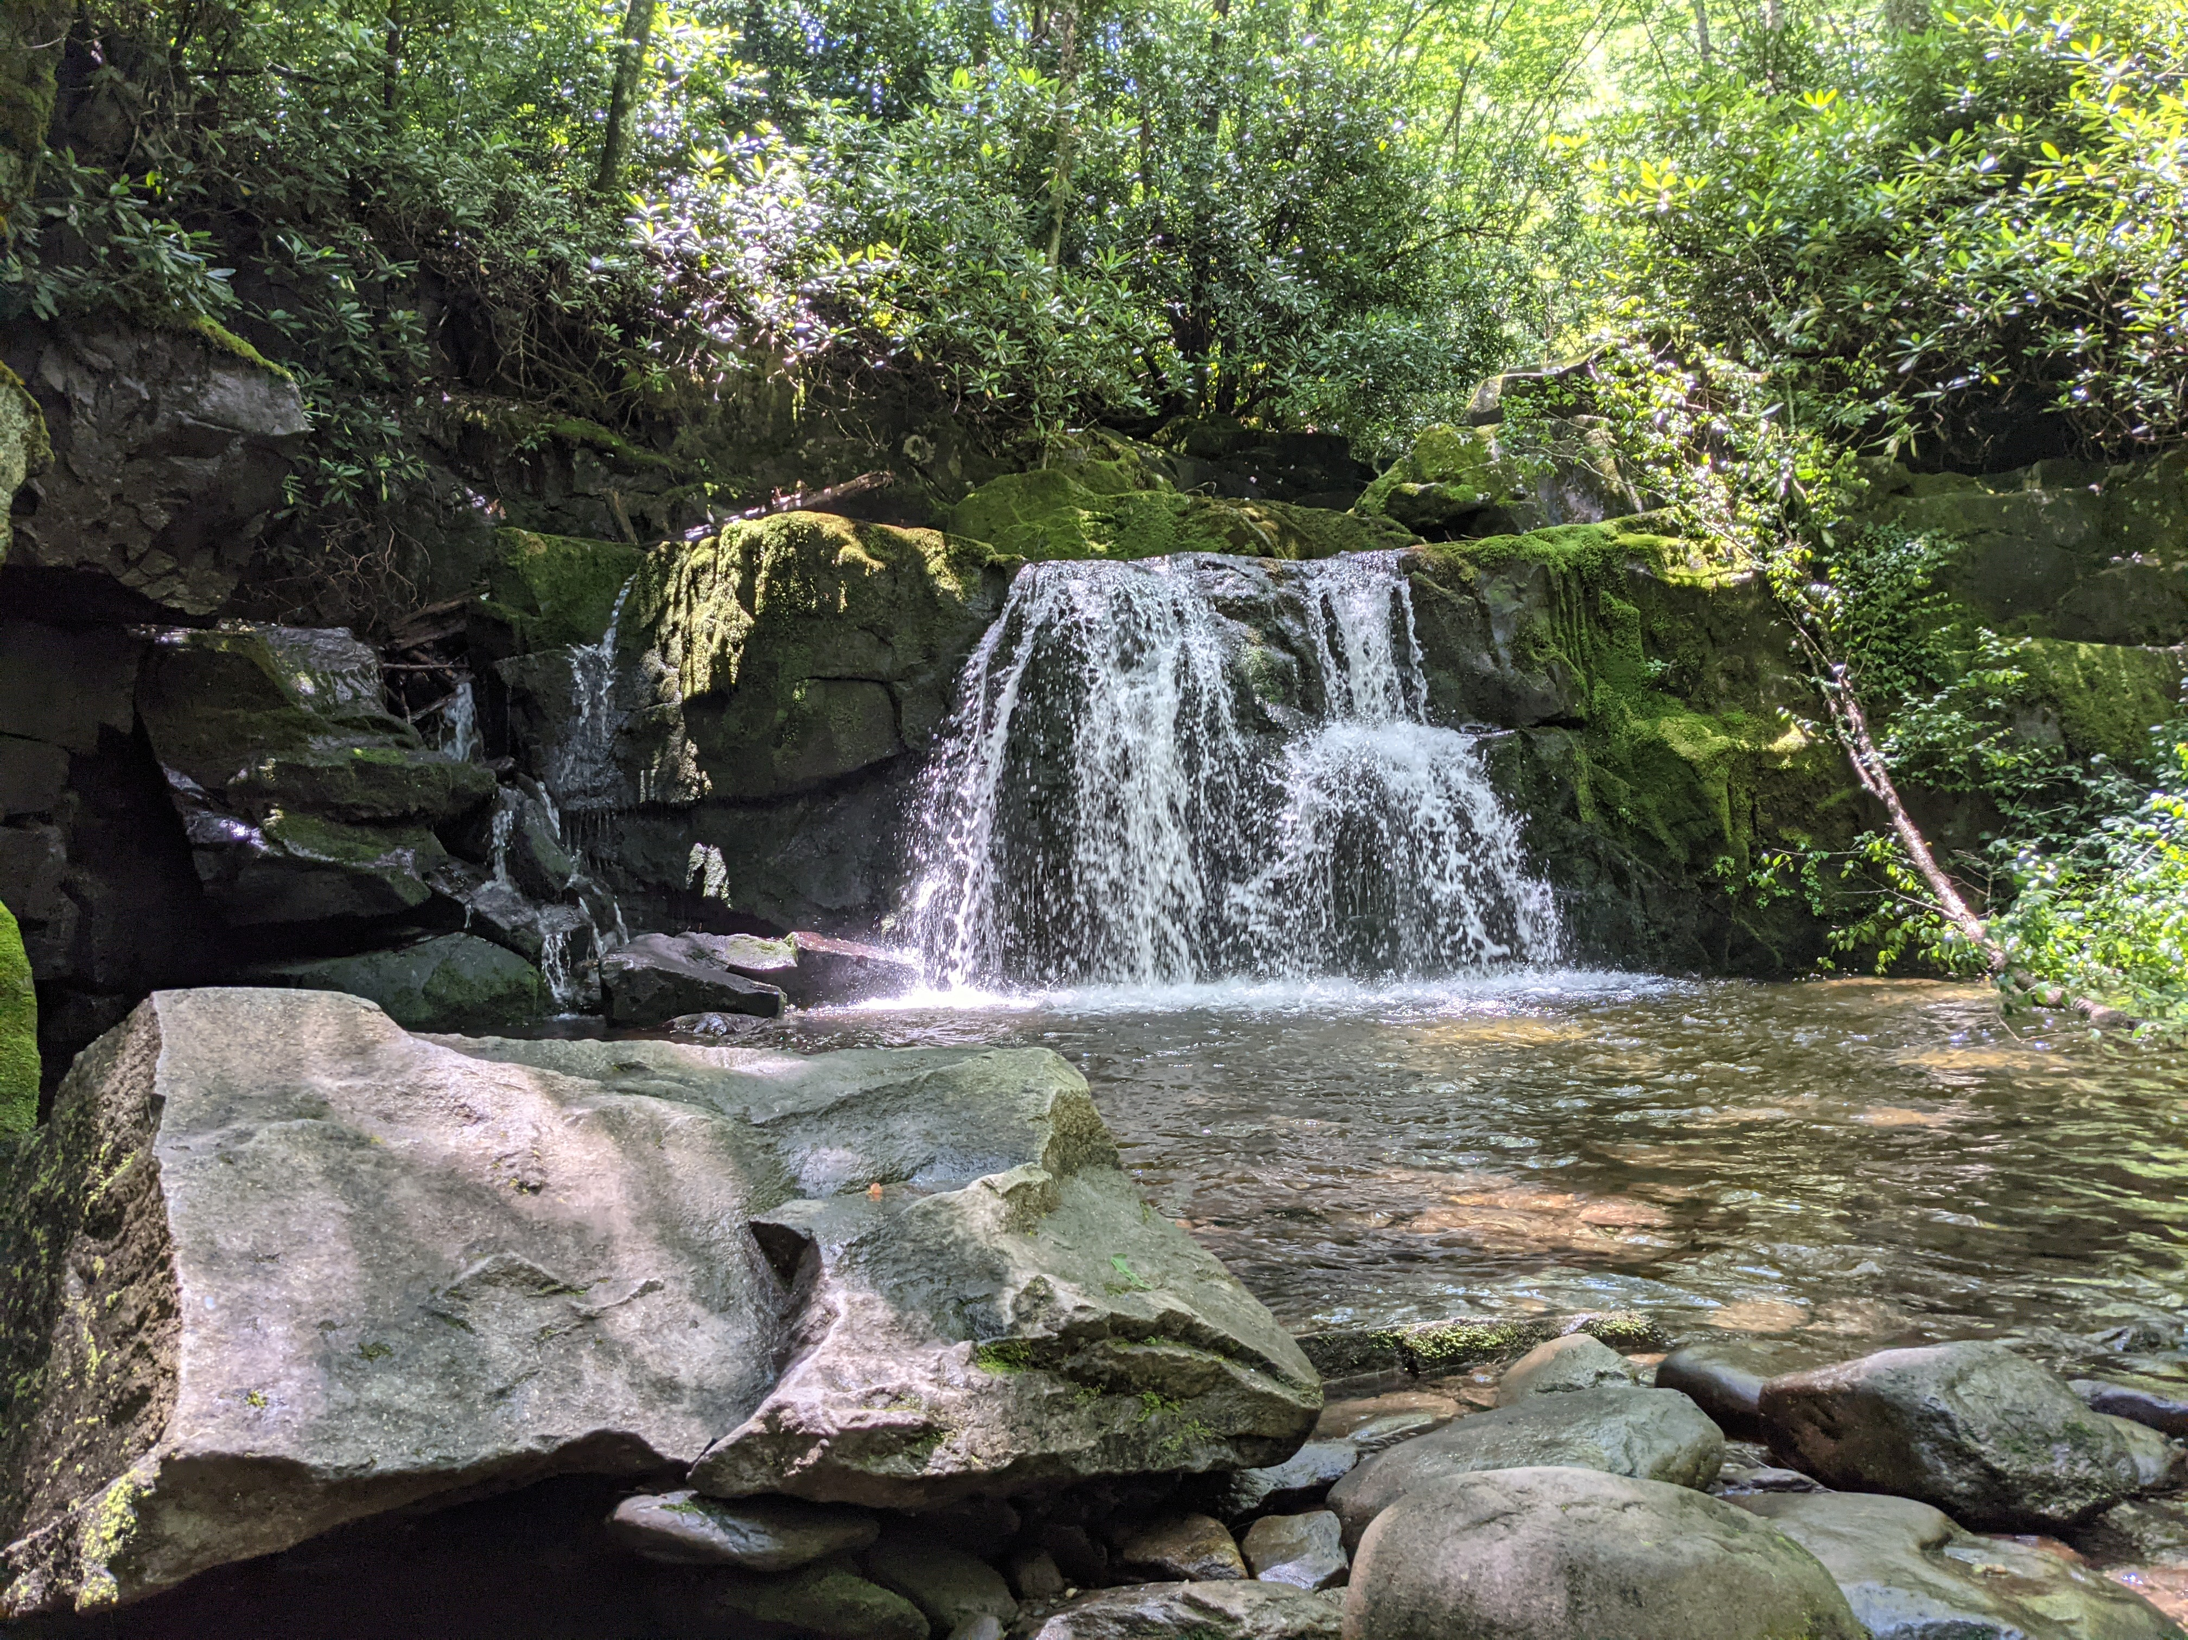

Photo credit to Katie and Joshua Rosenberg

### Key Characteristics

| **Characteristic** | **Details** |
| --- | --- |
| Time Estimate | 1 to 5 hours, depending on how far you hike |
| Trail Distance (Miles) | Up to 7.6 |
| Elevation Change | Moderate |
| Pets | Not Allowed |
| Parking Pass/Entrance Fee | Required |
| Restroom(s) | No |
| Best Ages | All Ages |
| Strollers and Wheelchairs | Not accessible |

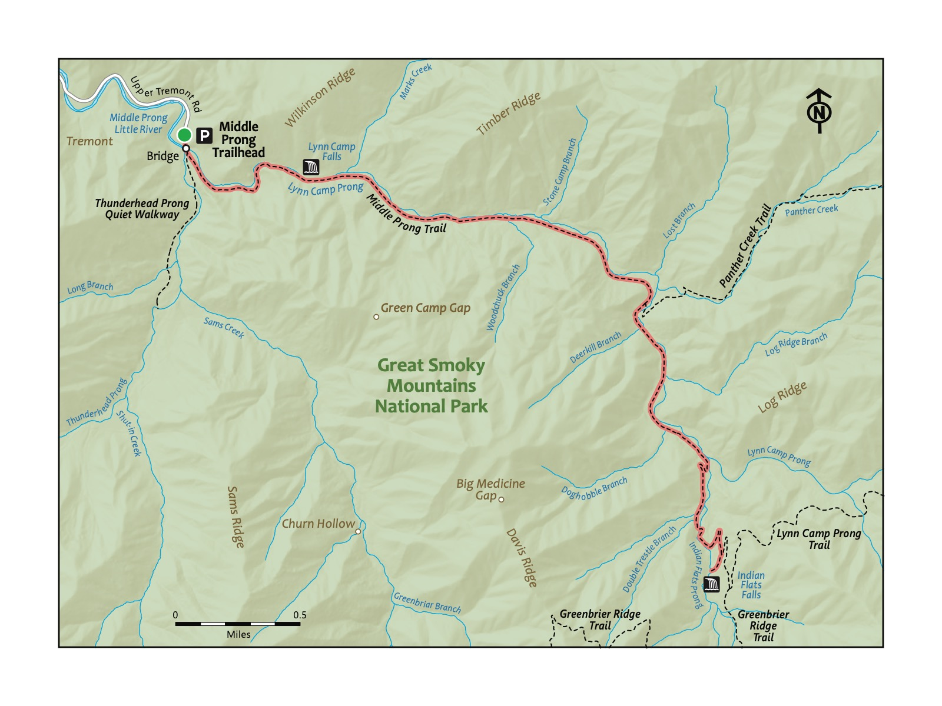

### Directions to the Trailhead

Trailhead Address: Middle Prong Trail Trailhead, J89J+54 Townsend, Tennessee

Trailhead GPS Coordinates: 35.61794, -83.66971

The above address will navigate you to the parking area for the trailhead. Please note it uses a “Plus code” in lieu of a street address that only works in Google Maps. Note that this trailhead is at the end of a lengthy gravel road, but it’s fairly smooth (and it’s a pretty drive). This is a large parking area. Even on the busiest days, you will be able to find a place to park. There are spots around the turn-around, but if they are taken, it is acceptable to park on the side of the road. After parking, walk toward the bridge to start your hike.

|  |  |
| --- | --- |
|  | **Brook Trout**  This native species of trout in Smokies streams is speckled and small and found at high elevations, whereas the Rainbow Trout and Brown Trout you’ll also see were later introduced for fishing. |

### Trail Description

| Distance from Start | Description |
| --- | --- |
| 0.0 | Cross the bridge over Lynn Camp Prong. Ascend gradually on the Middle Prong Trail. |
| 0.05 | Almost immediately past the bridge, not the split in the trail. This hike heads to the left. A short trail, the Thunderhead Prong Quiet Walkway, heads to the right (it’s a great place for kids to play and splash on hot days!). |
| 0.65 | Overlook to Lynn Camp Prong. Though a short way in, this is an acceptable spot to turn around and head back to the start. The trail continues onward. This is one of many trails in the Smokies that is pretty and very worthwhile all along the way; hike as far as you or your littles like. |
| 2.35 | Intersection with Panther Creek Trail on the left. Continue on the Middle Prong Trail. |
| 3.6 | Begin a brief switchback before the waterfall at the end of this hike. |
| 3.8 | Reach Indian Flat Falls. It’s accessible via a small opening in the trees and shrubs. After resting at the beautiful waterfall, turn around to return to the start. |
| 5.25 | Intersection with the Panther Creek Trail on the right. |
| 7.6 | Trailhead |

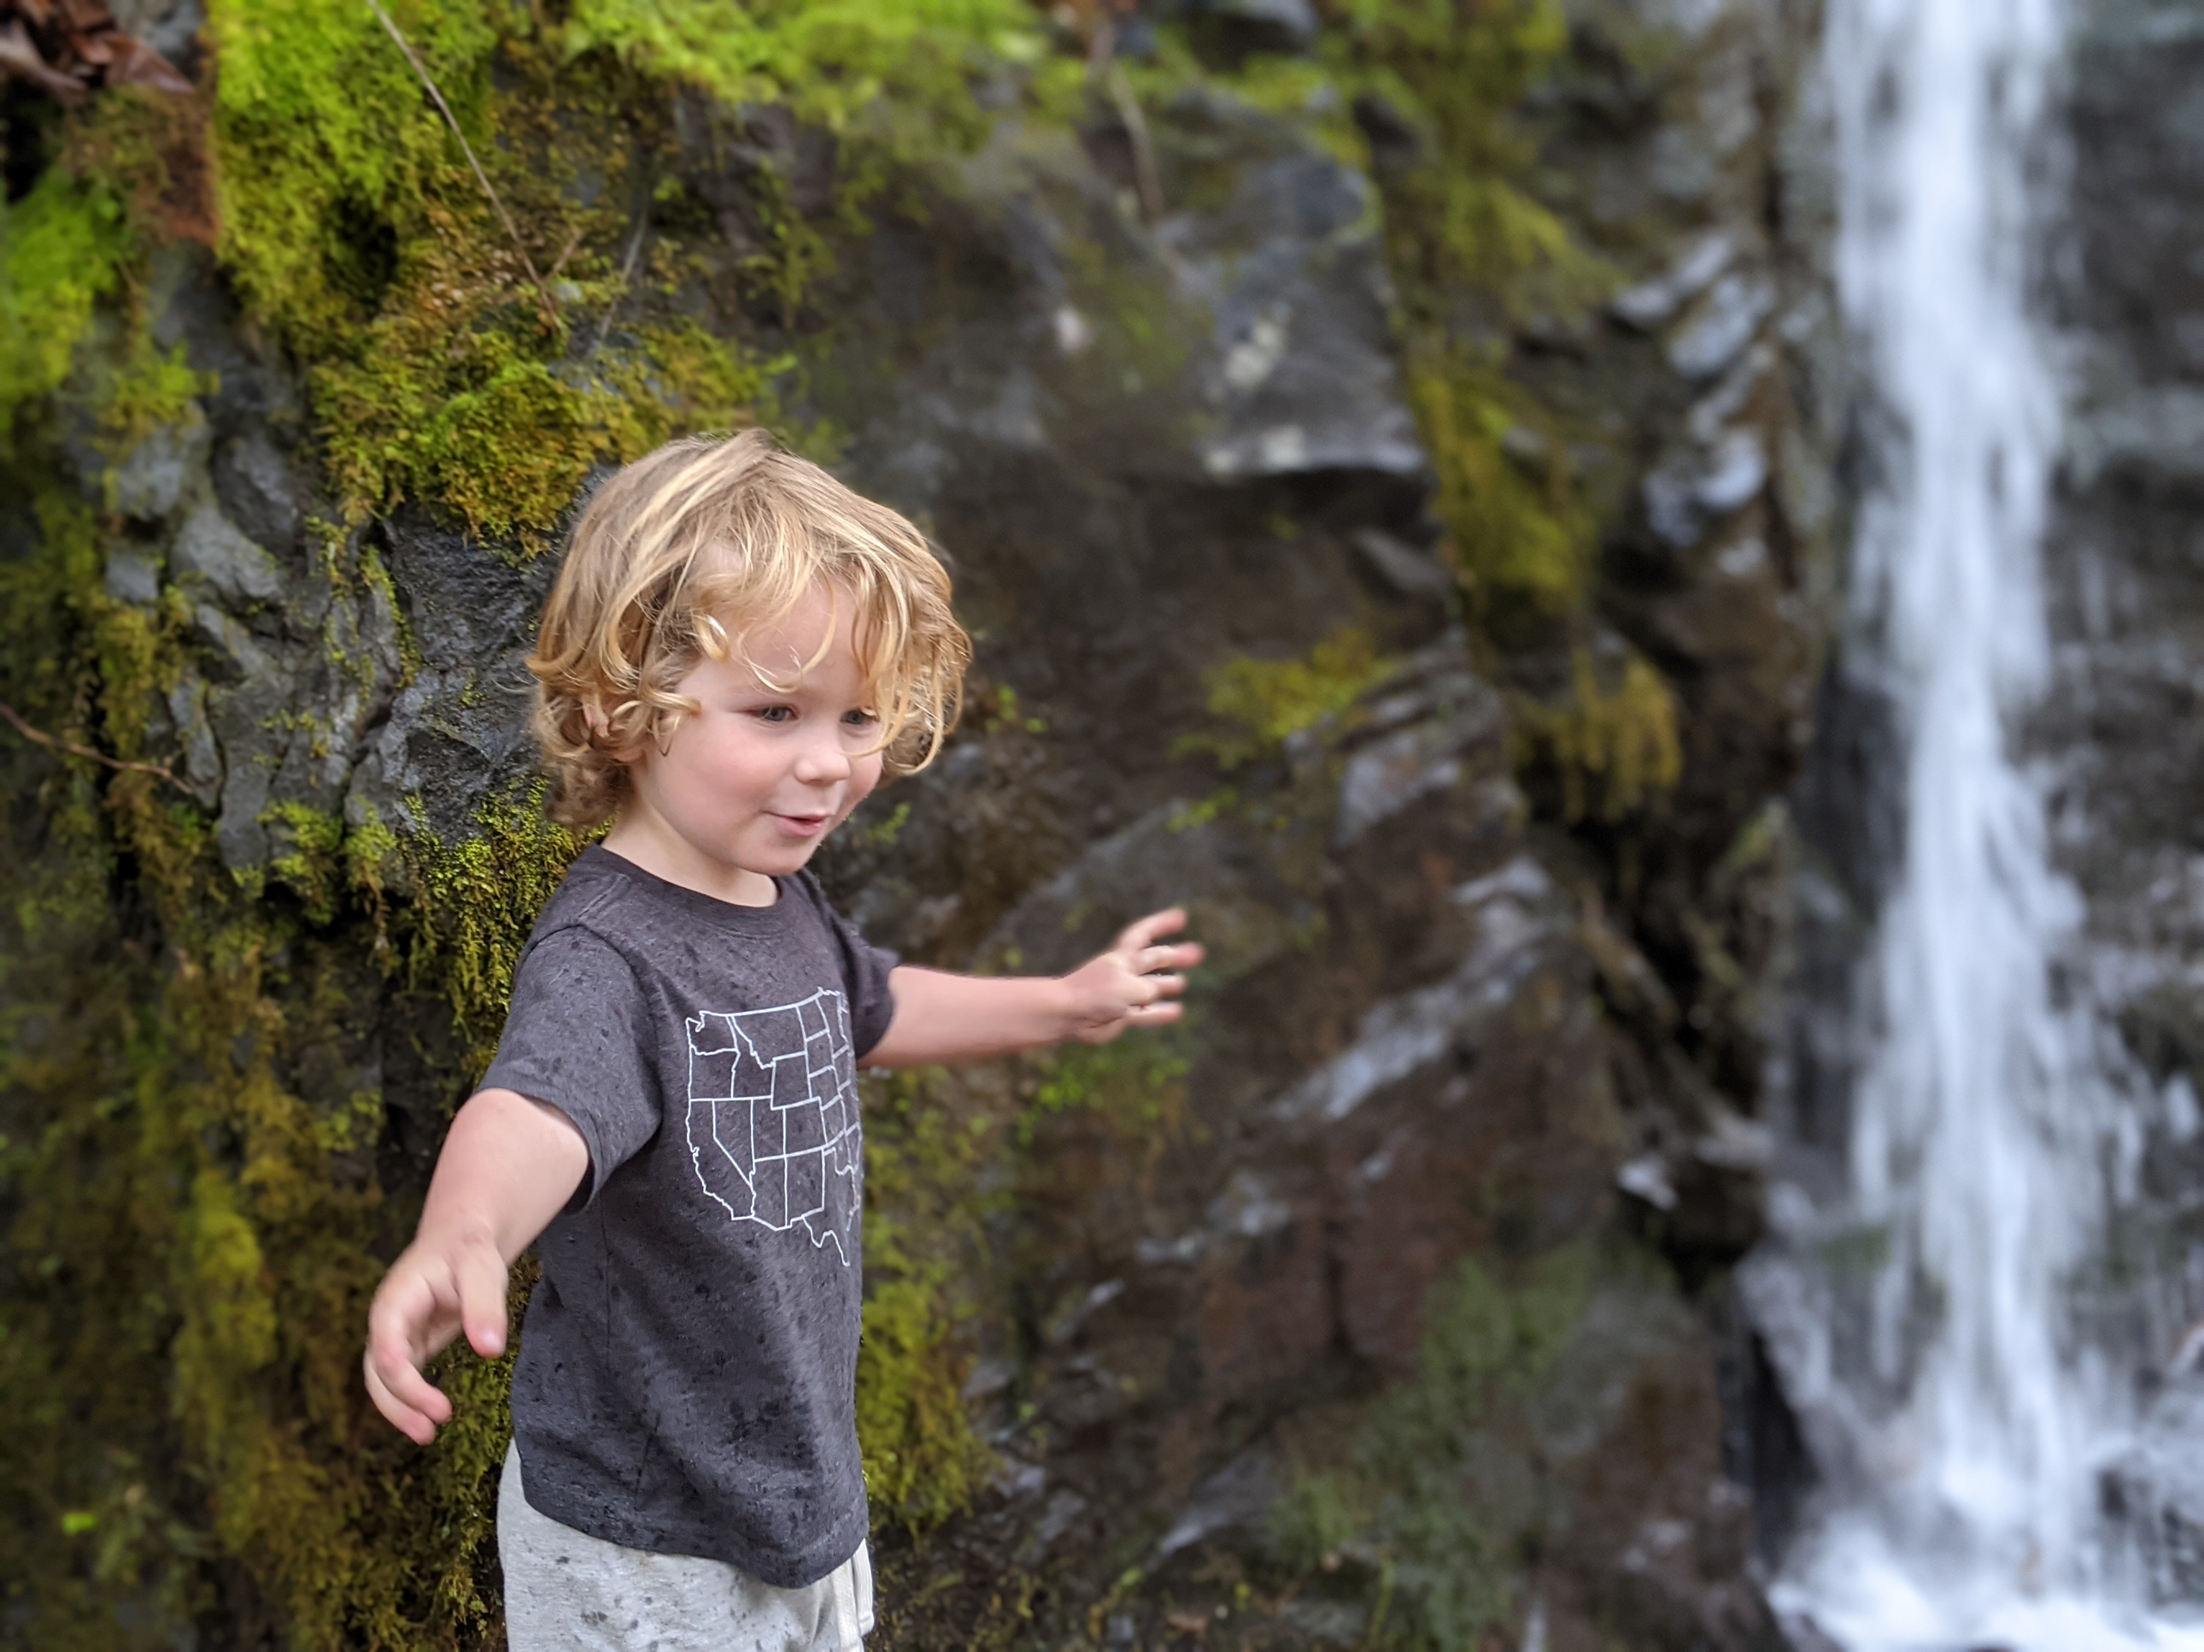

Photo credit to Katie and Joshua Rosenberg

### Nearby

* **Drive the Cade’s Cove Loop**. This is a nice way to make a longer day of your trip. Instead of returning the way you came, at the intersection of Townsend Road and Laurel Creek Road, turn left and head toward Cade’s Cove. The drive to Cade’s Cove is around 15 minutes; the loop road around Cade’s Cove takes around 45 minutes to drive–longer on busy days, especially when bears are visible–which is often! Traffic on the loop road can be severe, especially during peak times, so plan accordingly to avoid restless kiddos.
* **Stopping for a snack or meal in Townsend.** Townsend bills itself as the “Peaceful Side of the Smokies”. Peaceful Side Social is a favorite lunch and dinner spot with kids, owing to the good food and large outdoor play area.

# Deepening the Experience

You’ve made it a good number of miles; what’s next? This chapter speaks to ways of deepening the experience of hiking with little ones.

### Grow as a hiking family

If you’re anything like us, you’ll have rough days on the trail.

Further, if you’re like us, there may be seasons (or even entire years!) when hiking doesn’t quite “fit” like it has at other times.

We think that’s okay. A joy of spending time outdoor with family is that there do not need to be high expectations. We don’t need to hike all of the time or to have the latest outdoors gear. Instead, you—and we—can think of ourselves as growing as a hiking family.

Does the future hold yearly family outings to Seven Islands? Epic adventures into the depth of the Smokies? We don’t know where the memories we are forming now might lead; maybe that is part of the joy of hiking with little ones.

### Invite friends and family to join

Some of our best memories hiking come from inviting friends and family–especially those new to hiking. Like you may have with your kids, start small and take your time; maybe your kids can lead your guests!

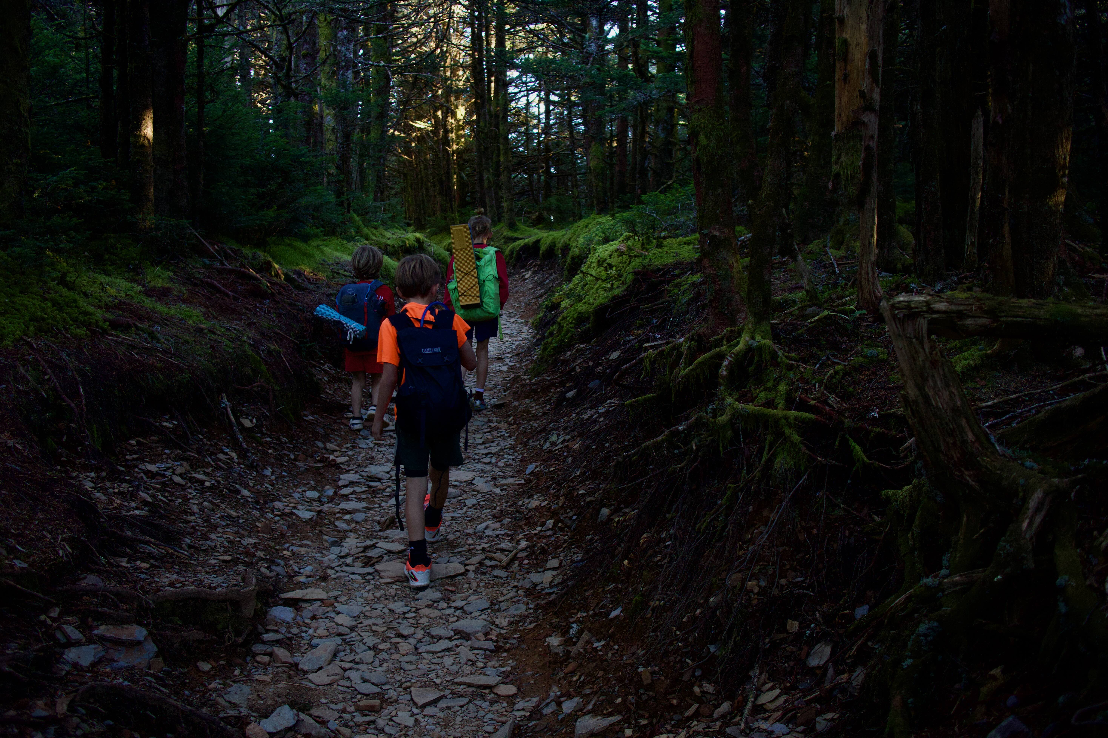

Photo credit to Katie and Joshua Rosenberg

### Go farther

Many of the hikes in this book are on a small part of longer trails. For example, the Alum Cave Bluffs hike in the previous chapter is around one-half of the way to the top of Mount LeConte, an epic hike to a truly majestic scenic overlook, Cliff Tops. You should try it after you develop confidence making it to the Bluffs. Particularly in the Smokies and the Cumberland Plateau, you can go (much) farther if you like. Which leads to our next two points.

### Camp

A great way to be closer to trailheads (and to have more time for long hikes) is to camp. If you haven’t gone before, consider asking friends to join.

Here are some favorite campgrounds; all have online systems that make it easy to reserve a spot:

* *Frozen Head State Park, Big Cove*: the ideal family campground, quiet, with giant boulders and a nearby creek for kids to splash in, clean restrooms, a playground, and even a rustic library nearby.
* *Smokies campgrounds*:
  + *Cades Cove*: The place to camp if you want to explore or bike (on Wednesdays in the summer and early fall) the Cades Cove Loop
  + *Elkmont*: Sprawling, and a little less spread out feeling than Cades Cove, but also a bit more scenic. Look for a site along the Little River.
  + *Cosby*: A hidden gem and one of our family’s favorites, with perhaps the most featureful quiet nature trail (not officially a trail in the Smokies!) that is connected to the campground. Mostly tent spots; has just a few spots for recreational vehicles.
* *Bandy Creek Campground*: In Big South Fork, this is a modern, spacious, friendly campground that seems to never approach being full. Close to many great hiking trails—and the horse stables.

### Try backpacking (really!)

Like for camping, if you’ve never been or considered backpacking, consider asking friends who have if they would like to go. These are often referred to as “backcountry” sites (in contrast to the “frontcountry” sites in campgrounds).

Here are some favorite spots for backpacking:

* *Smokies*:
  + *Backcountry Site #1*: You’ll see this on the Abrams Creek trail. Being only a one-mile hike to the site, this is a great first spot.
  + *Backcountry Site #17*: Also on the Abrams Creek trail, but considerably farther than Backcountry site #1. Super scenic, with many spots spread out in a bend of the creek.
  + *Backcountry Site #18*: Accessible from two trails, this site is nestled along a beautiful creek crossed by a bridge.
  + *Kephart Shelter*: One of 15 *shelters*, three-sided structures with two-level wooden floors for an easier setup (no tent required!). This shelter is a gentle and pleasant hike, but is a long drive from Knoxville.
  + *Icewater Springs Shelter*: A steep, around two-mile hike along the Appalachian trail is the path to this shelter.

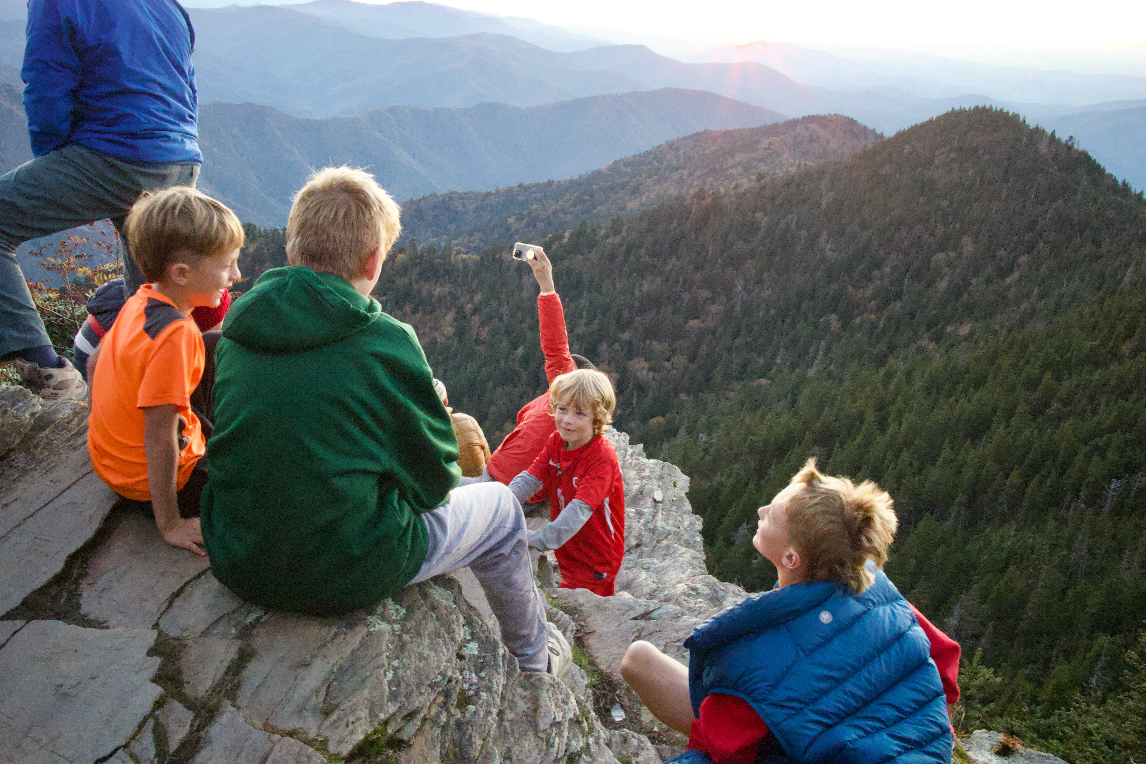

Photo credit to Katie and Joshua Rosenberg

* *Frozen Head State Park*:
  + *Bird Mountain*: A steep but pleasant hike up to one of the ridges of Frozen Head State Park. Passes Castle Rock, a unique and fun geologic feature.

# About the Authors

Katie Rosenberg is a parent and school librarian at L&N STEM Academy in Knoxville, TN.

Joshua Rosenberg is a parent and a faculty member in the College of Education, Health, and Human Sciences at the University of Tennessee, Knoxville.

# Appendix

# LKBA - Appendix

## Leave No Trace: Keeping the Wilderness Wild

These help preserve outdoor spaces for future adventurers.

### 1. Plan Ahead and Prepare

Check weather conditions before you go, and consider checking the website for the area you’ll be hiking in to ensure the trail is open and in good condition (the vast majority of the time, trails are open!). Pack appropriate gear and extra supplies, especially since you’ll be hiking with littles.

### 2. Travel and Camp on Durable Surfaces

Whenever possible, keep to established trails and campsites (we know one of our little hikers had a different tip in an earlier chapter!). Walk single file down the middle of the path - this protects trailside plants and prevents unnecessary erosion. When camping, look for hard, dry ground or existing sites that can handle the impact.

### 3. Pack It In, Pack It Out

Everything you bring must leave with you - food scraps, hygiene products, all of it. For bathroom breaks, if you can’t make it to a bathroom, look to go at least 200 feet from water sources. For number #2, try to dig a hole to prevent run off.

### 4. Leave What You Find

The outdoors is full of treasures. Admire them, photograph them, but it’s best to leave them where they are.

### 5. Minimize Campfire Impact

If you need or want to have a fire (when camping), use established rings or fire pans. Keep it small, stick to local dead wood, and ensure it’s completely cold before you leave.

### 6. Respect Wildlife

Watch animals from a distance - no following, no feeding, no disturbing their homes. Store food securely and keep garbage out of reach. If you bring a doggy, keep them under control and away from wildlife.

### 7. Be Considerate

The wilderness is for everyone. One small part of trail etiquette is to yield to those hiking *up* on a trail (it’s okay and understandable if little ones don’t consistently do this, but it’s a nice start to mention to those who are older!).

## Optional Gear

Consider these additions based on your route and conditions:

### Water Gear

* Water shoes
* Spare socks
* Change of clothes
* A towel

### Weather Protection

* Long-sleeve shirt
* Warmer layer (fleece, wool)
* Rain shell or windbreaker

### Extra Equipment

* Trekking poles (great for crossing creeks!)
* Child carriers if needed
* Sunscreen
* Insect repellent
* Emergency whistle (teach kiddos to use it if they get lost!)

## First-Aid Essentials

### Basic Kit

Perfect for day hikes and short adventures, here are just the basics that may be helpful to have:

1. Bandages in various sizes
2. Antibiotic ointment
3. Tweezers
4. Pain relievers
5. After bite stick (for bug bites)